

Mini Project – Product Service Management.

Submitted by

Harshit Jangde

**Table of Contents**

Contents

1 Project Objective 3

2 Assumptions 3

3 Step by step approach 5

3.1 Exploratory Data Analysis and descriptive statistics 5

3.1.1. Number of Rows and Columns: 9

3.1.3. Missing Values: 10

* 1. 3.2 Measures of Central Tendency: 10
  2. Splitting data in Train and Test dataset
  3. The relationship between Independent and Dependent Variables
  4. Model Development
* Random Forest
  1. Model Performance Measures
  2. Validation of Model
  3. Model Performance on Hold Out Sample

4Conclusion……………………. 35

5 Appendix – Source Code 36

# Project Objective

This case is about a bank (Thera Bank) which has a growing customer base. Majority of these customers are liability customers (depositors) with varying size of deposits. The number of customers who are also borrowers (asset customers) is quite small, and the bank is interested in expanding this base rapidly to bring in more loan business and in the process earn more through the interest on loans. **In particular, the management wants to explore ways of converting its liability customers to personal loan customers (while retaining them as depositors)**. A campaign that the bank ran last year for liability customers showed a healthy conversion rate of over 9% success. This has encouraged the retail marketing department to devise campaigns with better target marketing to increase the success ratio with minimal budget. **The department wants to build a model that will help them identify the potential customers who have higher probability of purchasing the loan**. This will increase the success ratio while at the same time reduce the cost of the campaign. The file Bank.xls contains data on 5000 customers. The data include customer **demographic information (age, income, etc.),** the customer's relationship with the bank (mortgage, securities account, etc.), and the customer response to the last personal loan campaign (Personal Loan). Among these 5000 customers, only 480 (= 9.6%) accepted the personal loan that was offered to them in the earlier campaign.

**Build a model that will help them identify the potential customers who have a higher probability of purchasing the loan.**

# Assumptions

The sample size of the data set is 5000 (> 30) from each model of **Thera bank**. **Central Limit Theorem states that irrespective of the shape of the original population, the sampling distribution of the mean will approach a normal distribution as the size of the sample increases and becomes large (>30)**. We also assume that the sample estimate will be reflective of the reality.

**Thera bank Dataset (Screen shot of partial dataset):-**

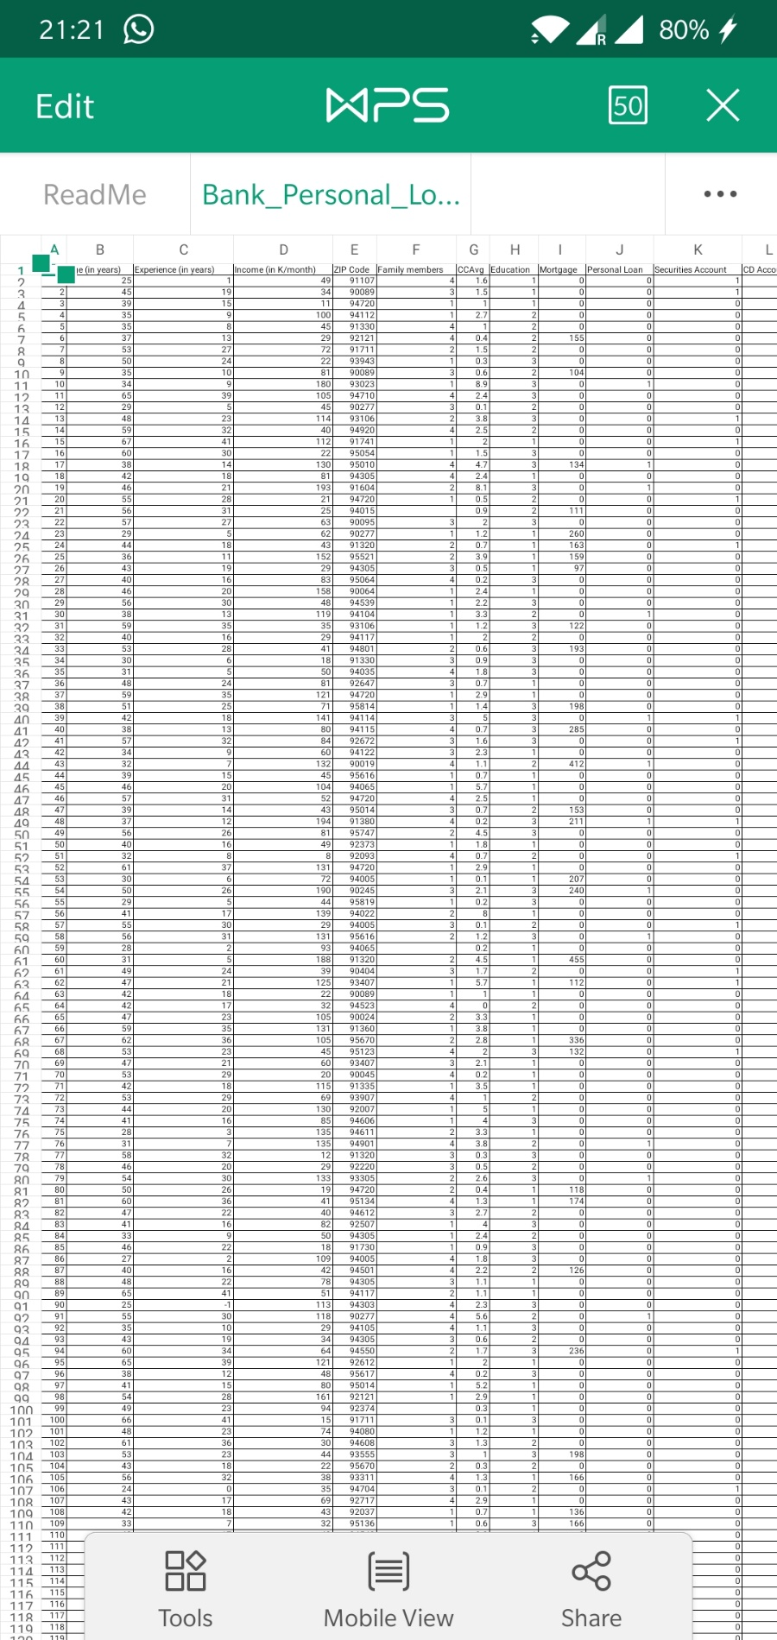

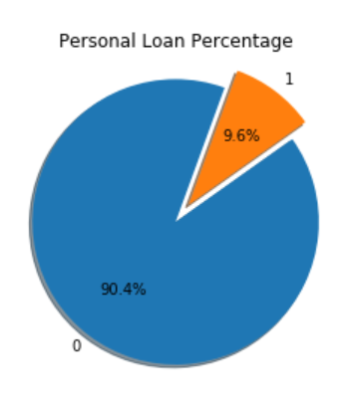

# Step by step approach

We shall follow step by step approach to arrive to the conclusion as follows:

* 1. Exploratory Data Analysis
  2. Descriptive Statistics
  3. Splitting data in Train and Test dataset
  4. The relationship between Independent and Dependent Variables
  5. Model Development
* Random Forest
  1. Model Performance Measures
  2. Validation of Model
  3. Model Performance on Hold Out Sample

## Exploratory Data Analysis and descriptive statistics

* install.packages("psych")

## library("psych")

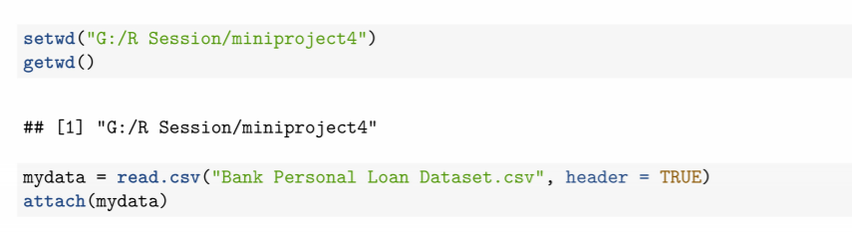

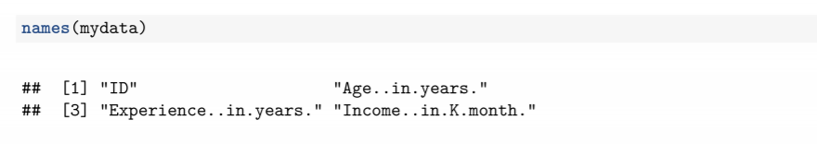

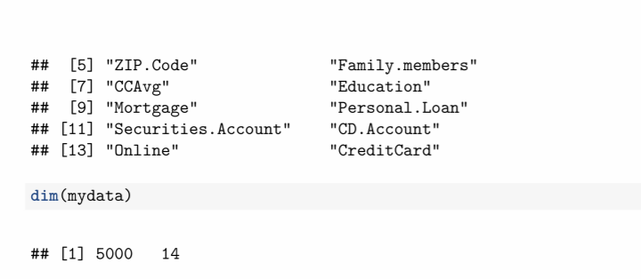

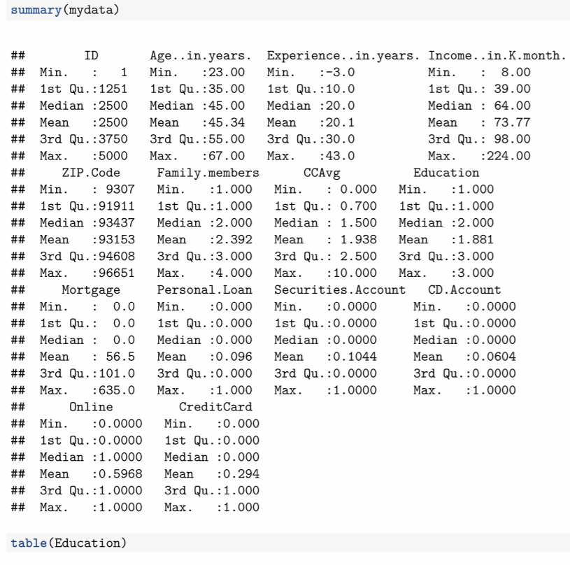

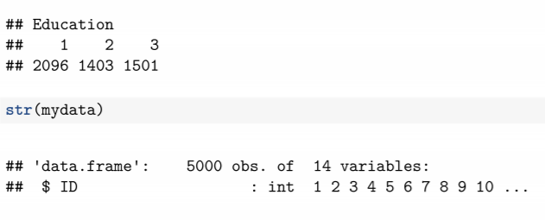

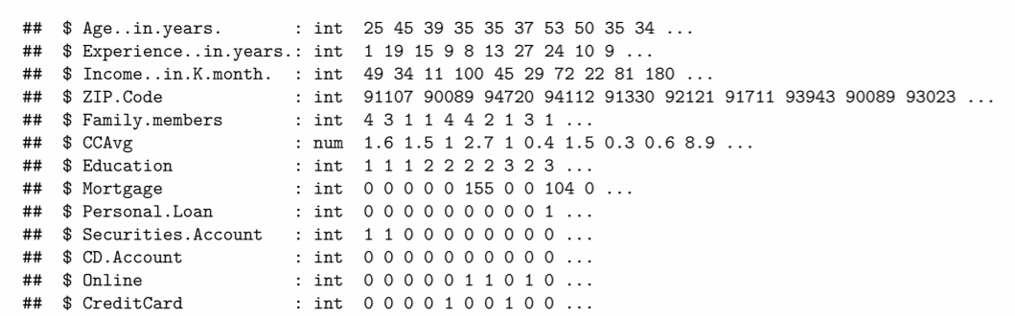

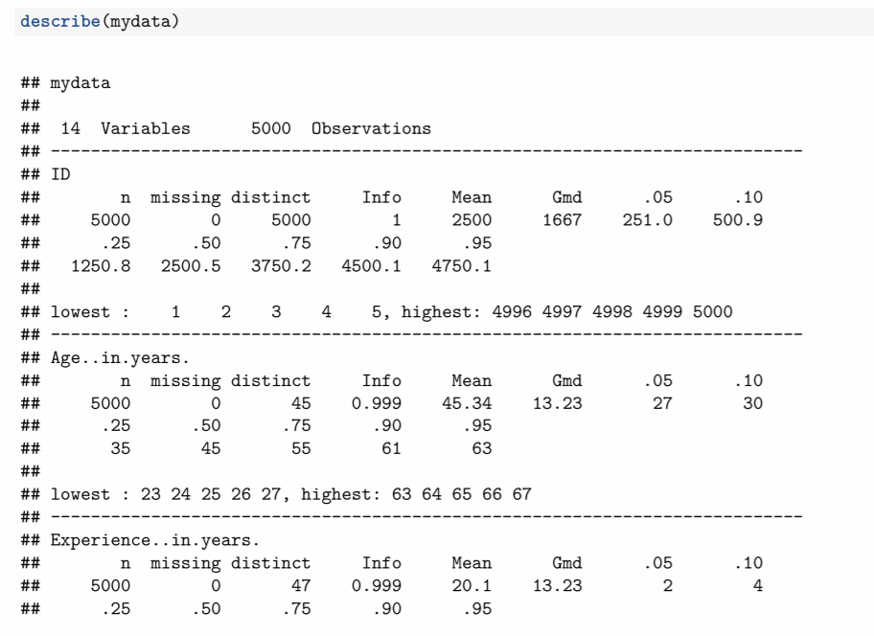

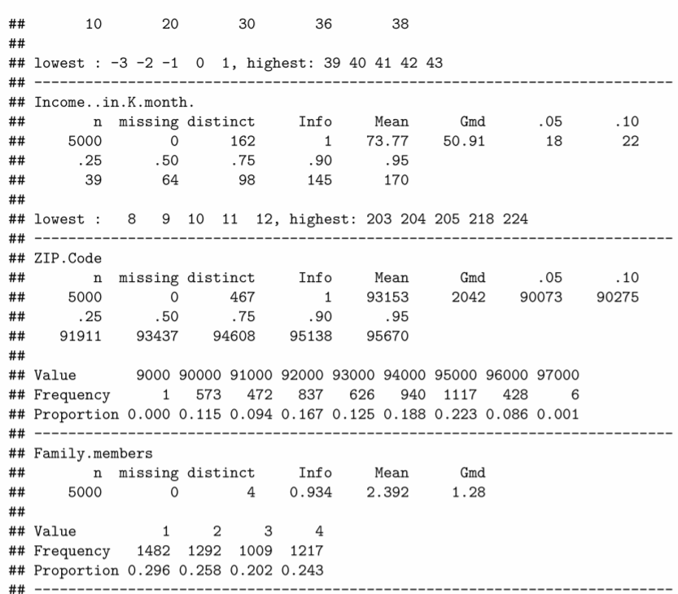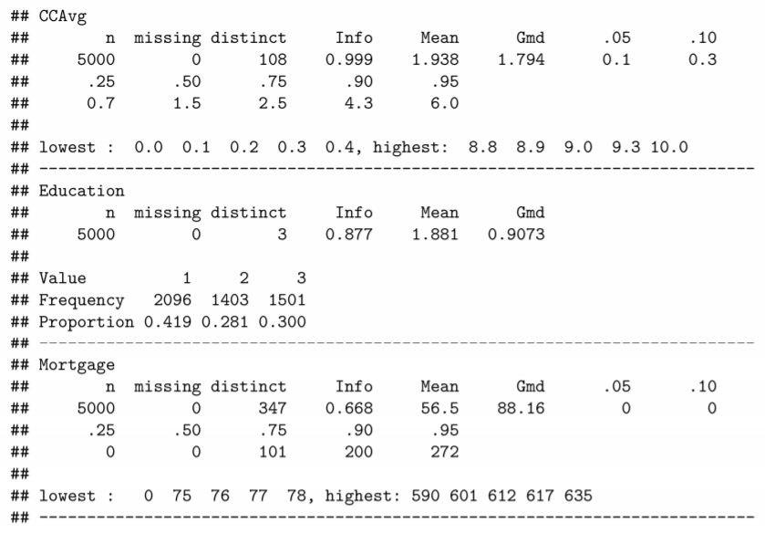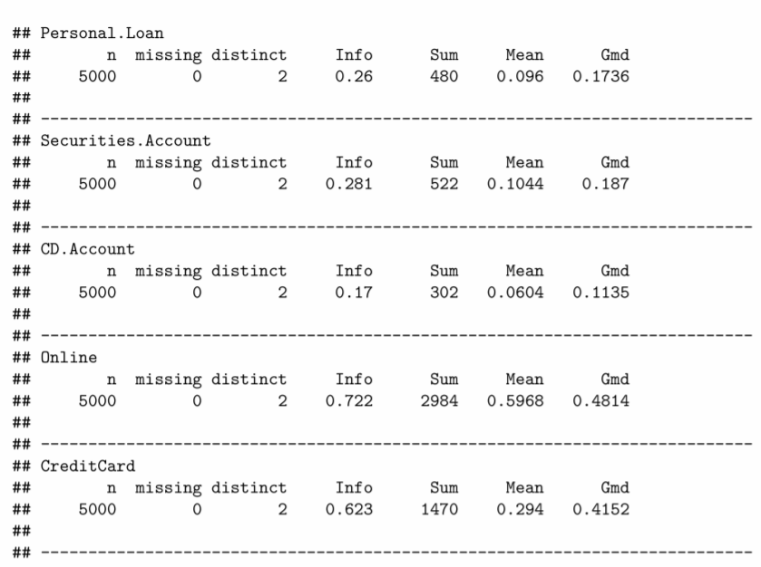

### 3.1.1. Number of Rows and Columns:

* The number of rows in the dataset is 5000
* The number of columns (Features) in the dataset is 14 but we will use 13.

(Feature ID will be deleted, since it does not have any significance)

**Now deleting ID subset**

* + data<-subset(mydata, select = -c(1))
  + names(data)

We can see ID’s column will be omitted

**3.1.2 Categorical and Continuous Variables**

|  |  |
| --- | --- |
| **Feature Names** | **Types** |
| ID | Integer |
| Age..in.years. | Integer |
| Experience..in.years. | Integer |
| Income..in.K.month. | Integer |
| ZIP.Code | Integer |
| Family.members | Integer |
| CCAvg | Num |
| Education | Integer |
| Mortgage | Integer |
| Personal.Loan | Integer |
| Securities.Account | Integer |
| CD.Account | Integer |
| Online | Integer |
| CreditCard | Integer |

### 3.1.3. Missing Values:

* + - 1. The data was checked for Missing Values using R function colsums(is.na),
      2. Plot of missing value is obtain by function plot_missing(data)

And found **18 missing values** in feature family member, which I had replaced with 1.

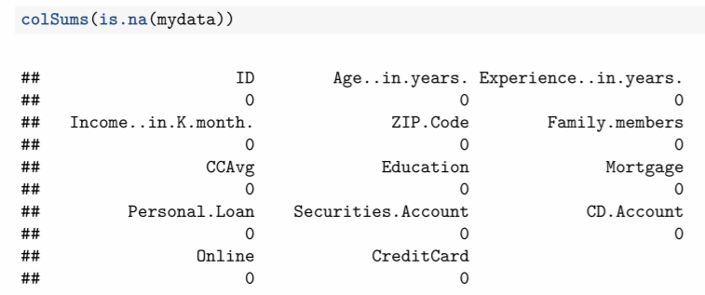

Data Visulisation and Graphical Representation

UNDERSTAND THESE GRAPHS

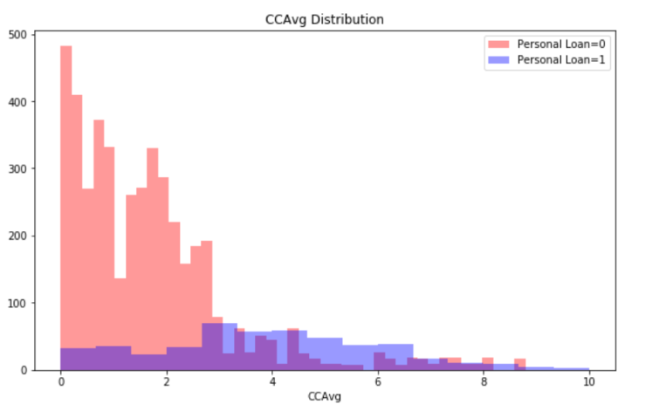 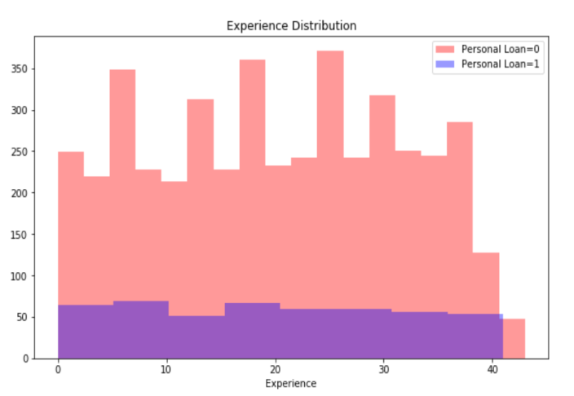

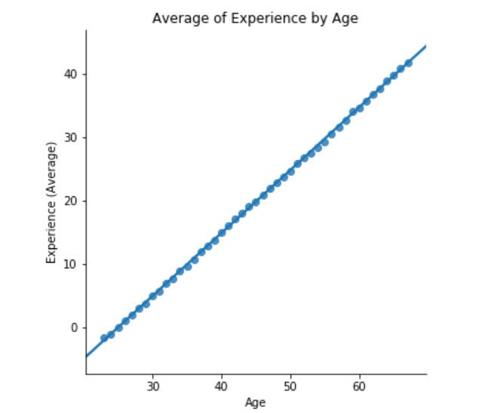 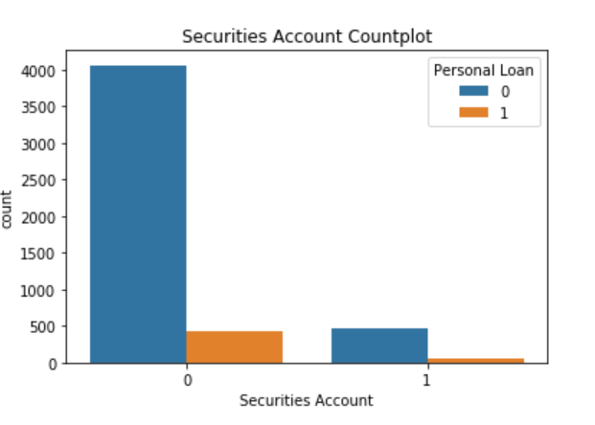

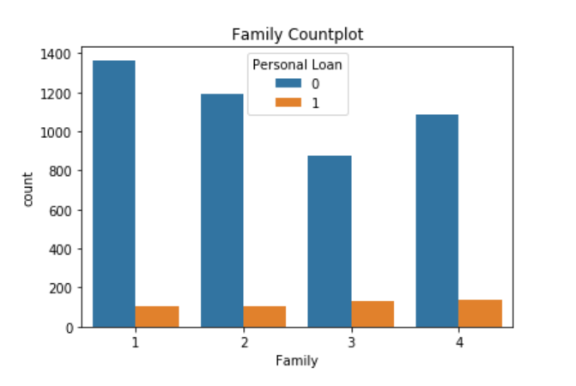 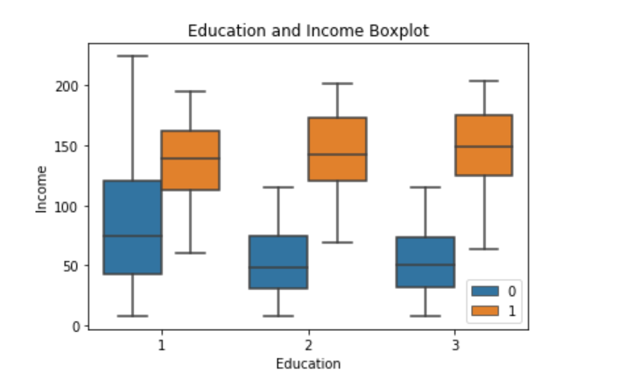 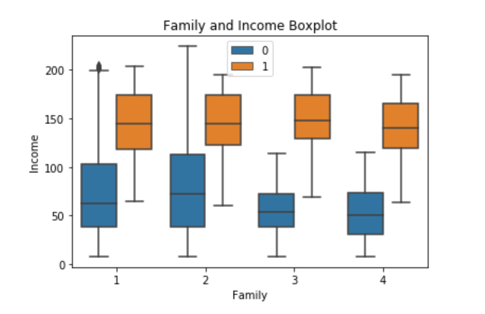

Taken help of internet for the visualisations and graphical representation

### Measures of Central Tendency:

|  |  |  |
| --- | --- | --- |
| **Measures of Central Tendency** | **Measures of Dispersion** | **Visualization Method** |
| Mean | Range | Histogram |
| Median | 1st Quartile | Boxplot |
| Mode | 3rd Quartile |  |
| Minimum | Inter Quartile Range (IQR) |  |
| Maximum | Variance |  |
|  | Standard Deviation |  |

Splitting data in Train and Test dataset

One of the very common issues while developing Machine Learning systems is *overfitting***.**

Let me give you a classical example.

Suppose, you have built a model to predict housing prices in a particular region. This is typically a Linear Regression model.

Now, the region is big, big enough so that you had enormous amount of actual data, but of course there are a lot more houses in the region than the amount of data you have used to train your model.

When you train your model, it tries its best to find out some kind of pattern in your training data while minimizing the error rate. But we only want our model to find *pattern*. Not more than that.

Why? Because if your model just tries to go beyond finding patterns, it may memorize the training data. Look at the image below:

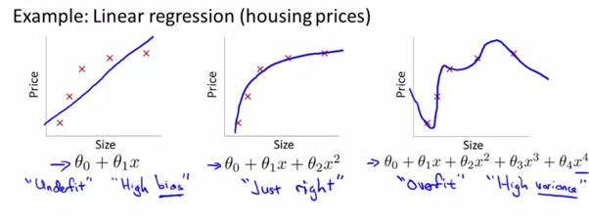

[Source](https://kousikk.wordpress.com/2014/11/20/problem-of-overfitting-in-machine-learning/)

In the leftmost graph, your model has not quite understood any pattern in your data. We call it underfitting - it fits the data worse than it should.

The middle one depicts a model which has found a *just right* pattern in the training data. This is quite reasonable.

The third one is a model where things are pretty much messed up.

In the third one, your model has found a pattern in the training set, but it has kind of memorized it! If you check out the training accuracy for this particular model, you will see that the accuracy is just 100% with simply 0 error. But will this model outperform the middle one in newer examples?

This is one of the reasons we need to use training and test set separation. After we have trained our model, we should test it on fresh examples so that we can avoid problems like overfitting. We can also estimate how well our model is performing given that it is facing new inputs. Based on the performance, we can proceed on developing our system further.

The point is, good accuracy in training set can ensure nothing.

In fact, a more encouraged technique is to divide your data set into three classes: [*training set, cross validation set and test set.*](https://stats.stackexchange.com/questions/19048/what-is-the-difference-between-test-set-and-validation-set)The validation set is used to tune the model.

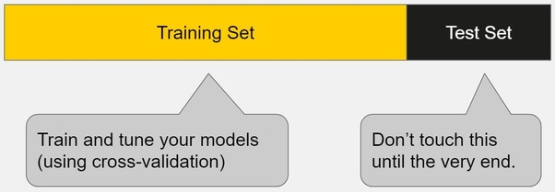

**Theory is taken from QUORA for understanding the concept**

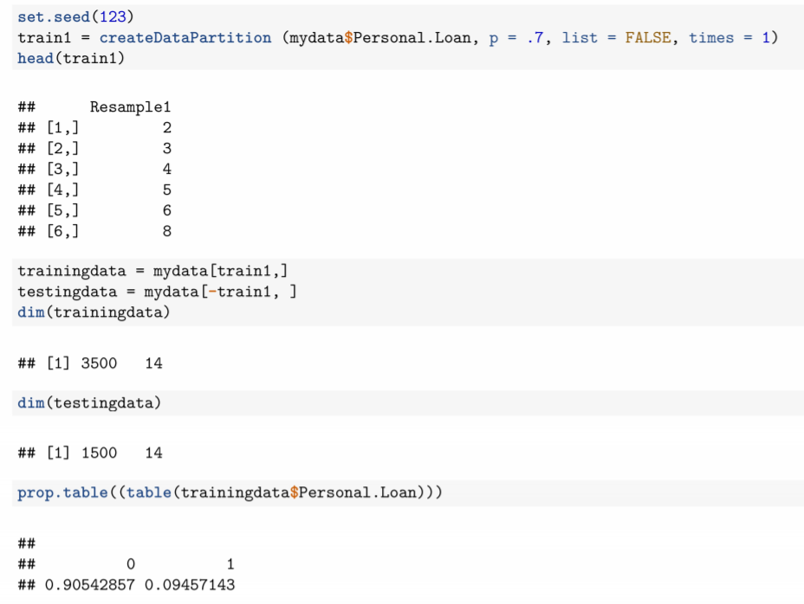

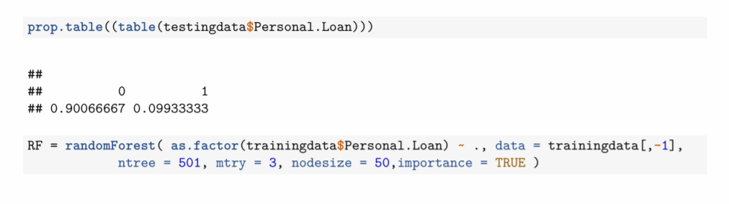 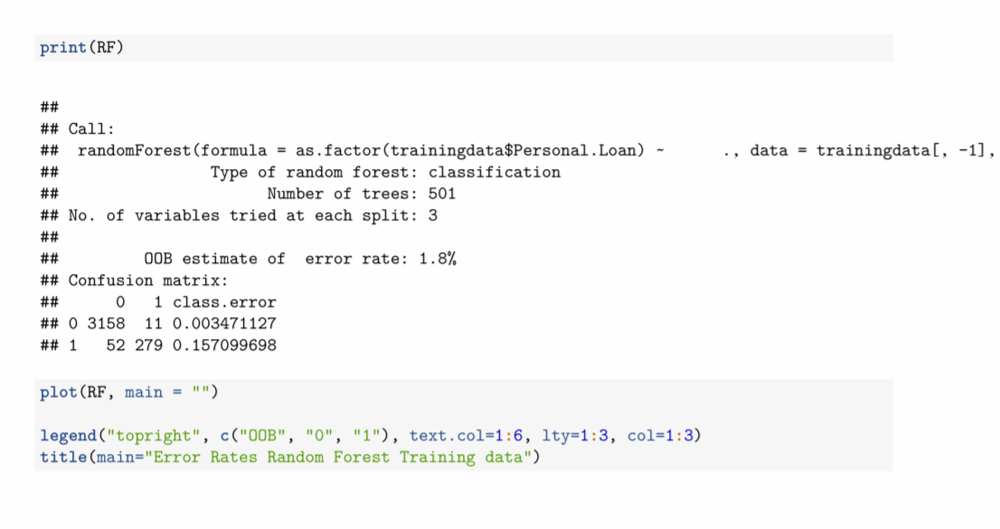 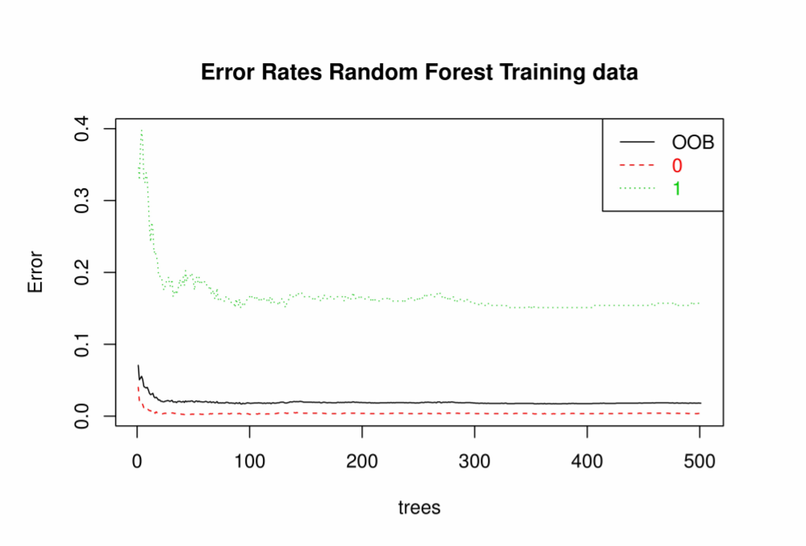

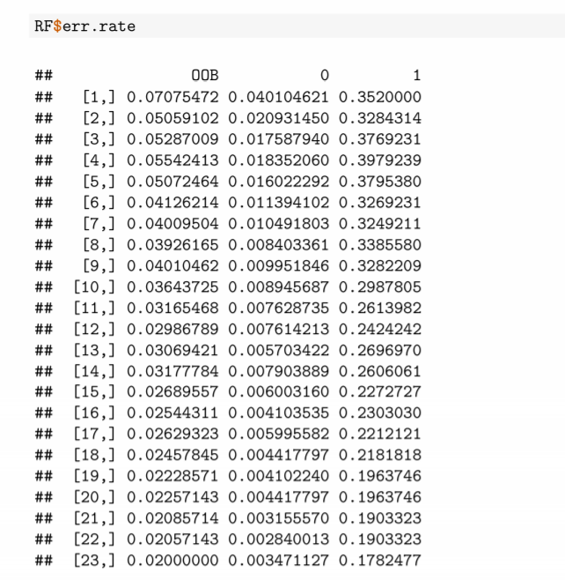

.

.

.

.

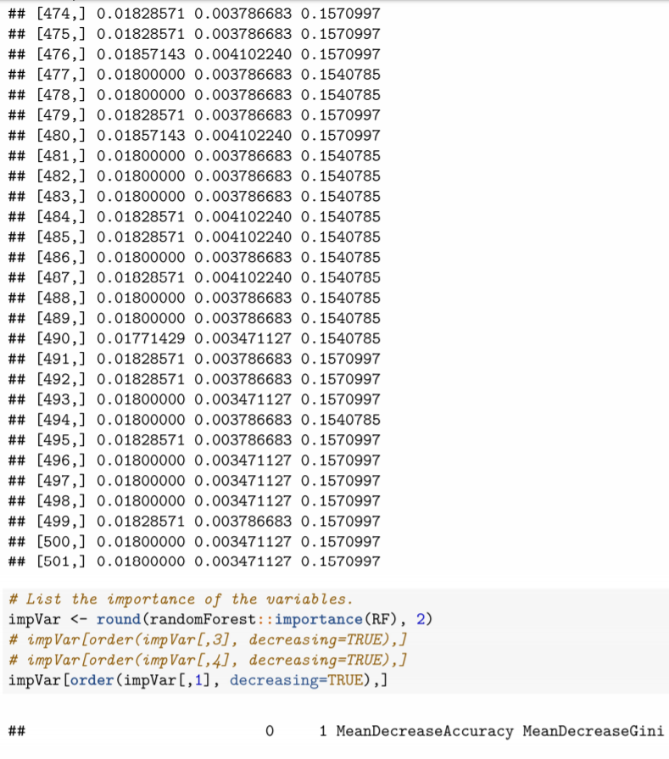 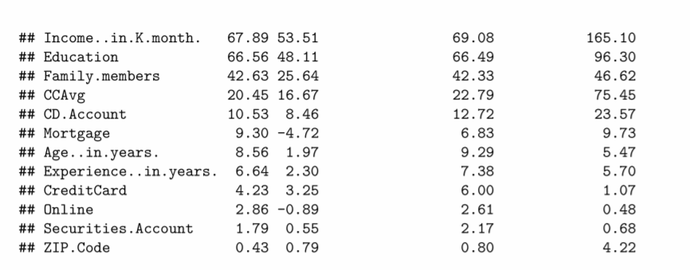

|  |
| --- |
|  |
|  |

## Evidence of Multicollinearity

It’s essential to comprehend the following terms:

* **Dependent Variable:** This is the main factor that you are trying to understand or predict.
* **Independent Variables:** These are the factors that you hypothesize have an impact on your dependent variable.

Multicollinearity is the occurrence of high intercorrelations among independent variables in a multiple regression model.  Multicollinearity can lead to skewed or misleading results when an analyst attempts to determine how well each independent variable can be used most effectively to predict or understand the dependent variable in a statistical model.

In general, multicollinearity can lead to wider confidence intervals and less reliable probability values (P values) for the independent variables.

### How to detect Multicollinearity?

### Multicollinearity exists when two or more of the predictors in a regression model are moderately or highly correlated. Unfortunately, when it exists, it can wreak havoc on our analysis and thereby limit the research conclusions we can draw.

### Multicollinearity occurs when independent variables in a regression model are correlated. This correlation is a problem because independent variables should be independent. If the degree of correlation between variables is high enough, it can cause problems when you fit the model and interpret the results.

### How to find the presence of multicollinearity

1. Examination of Correlation Matrix:
2. Variance Inflation Factor:
3. Eigen system Analysis of Correlation Matrix:

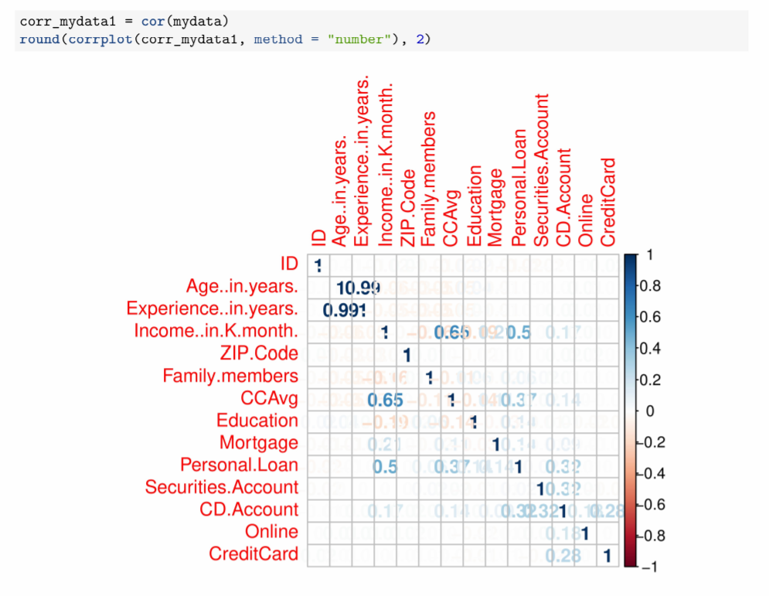

**Observations:**

The followings are highly correlated

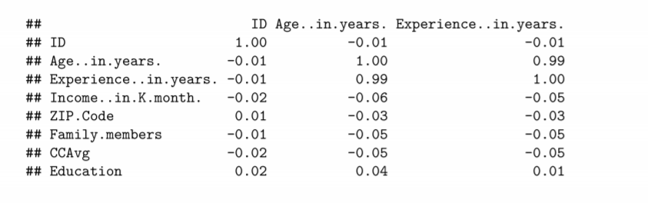 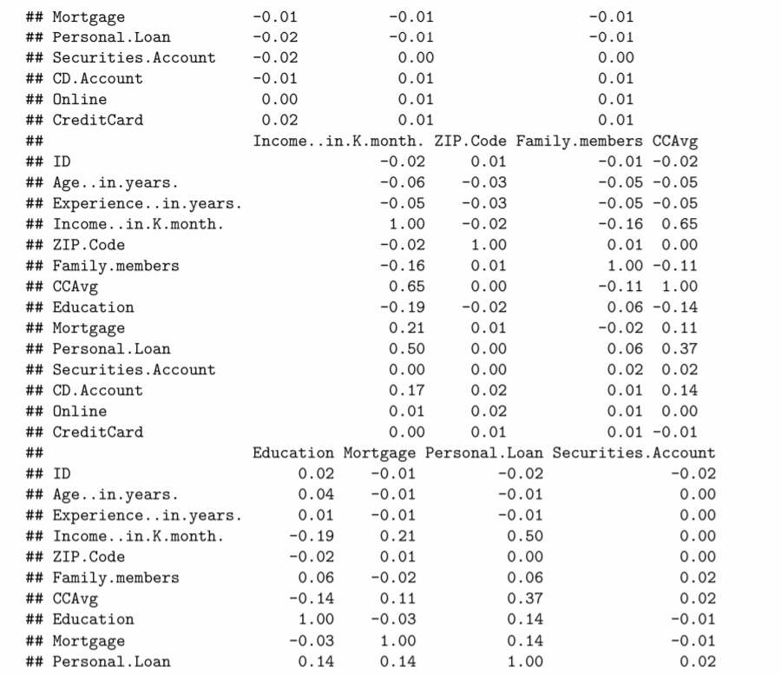 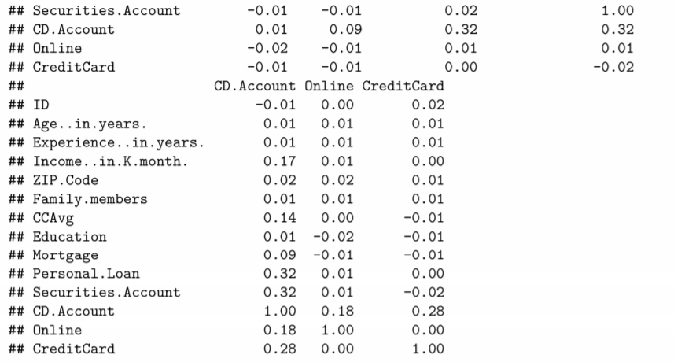

 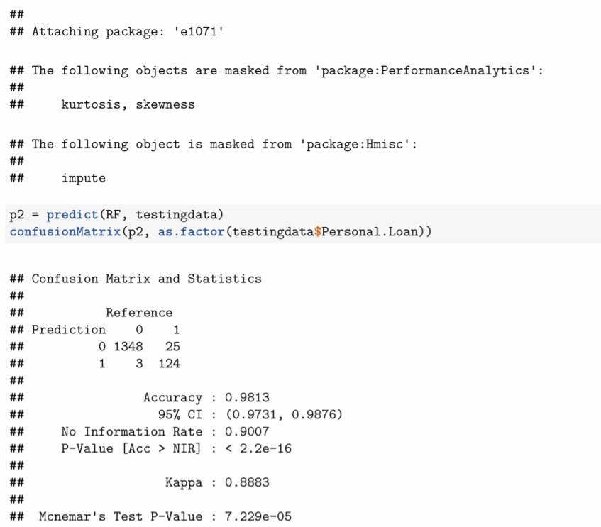 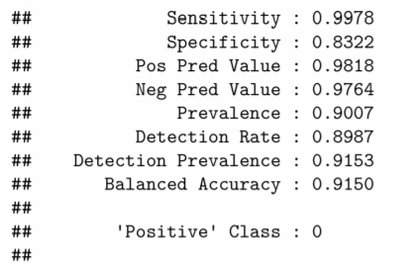

3.5. **Model Development**

* + Random Forest

 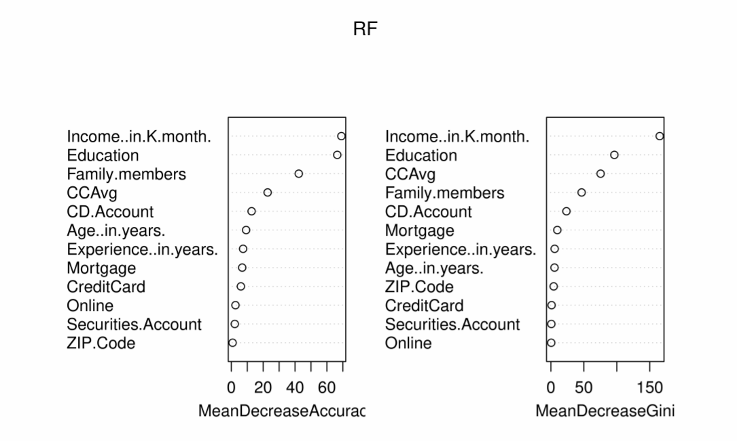 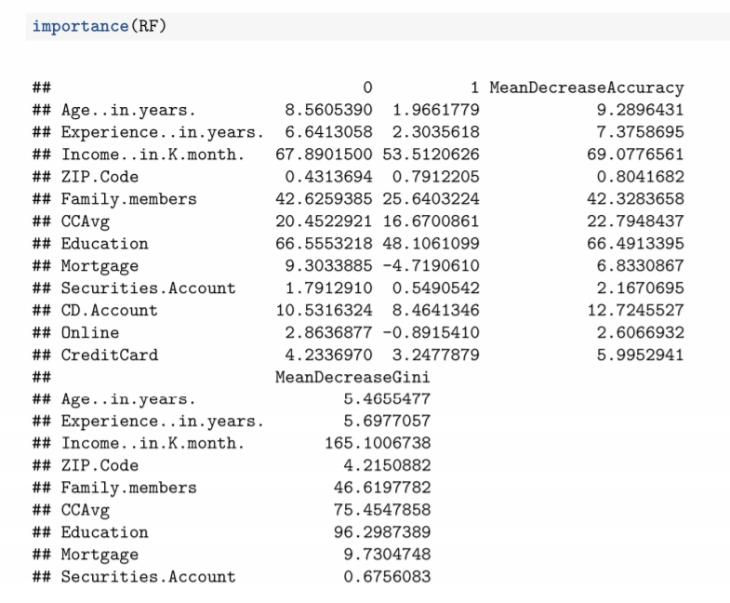 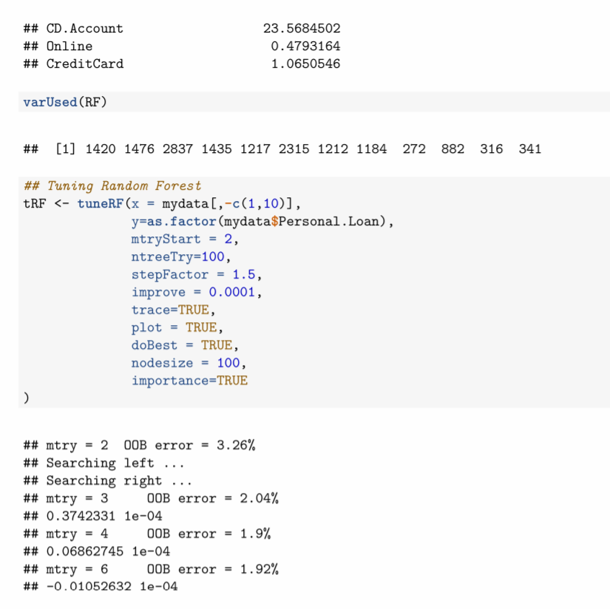

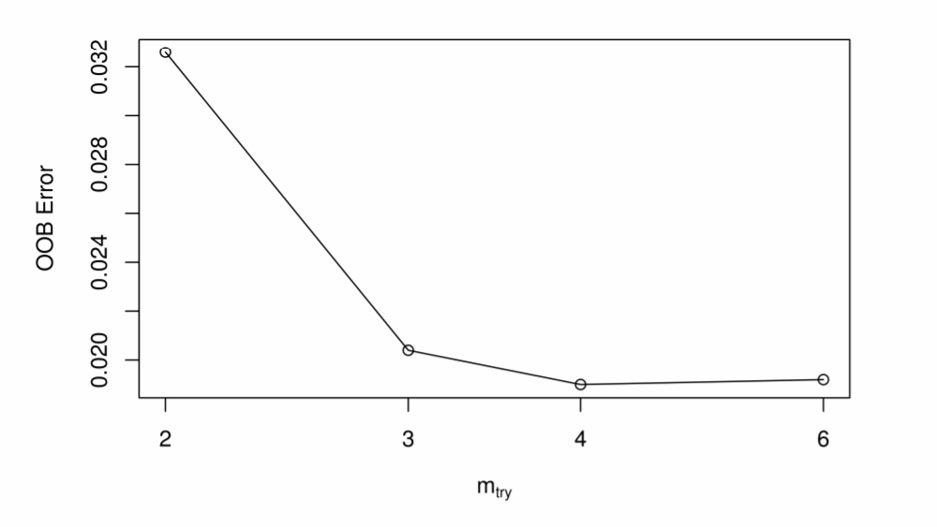 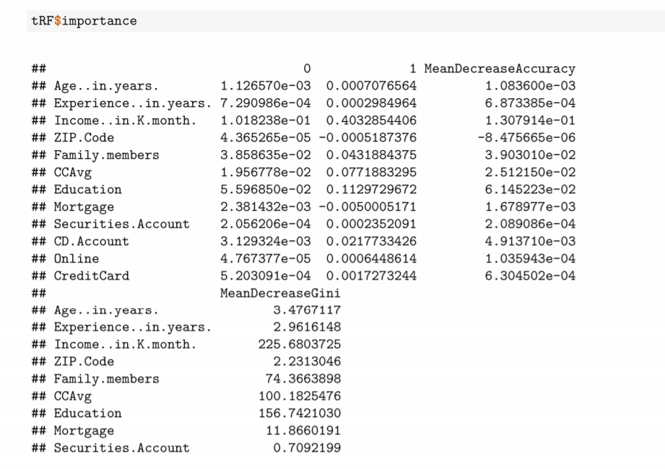 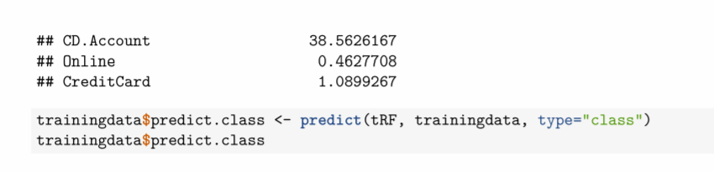 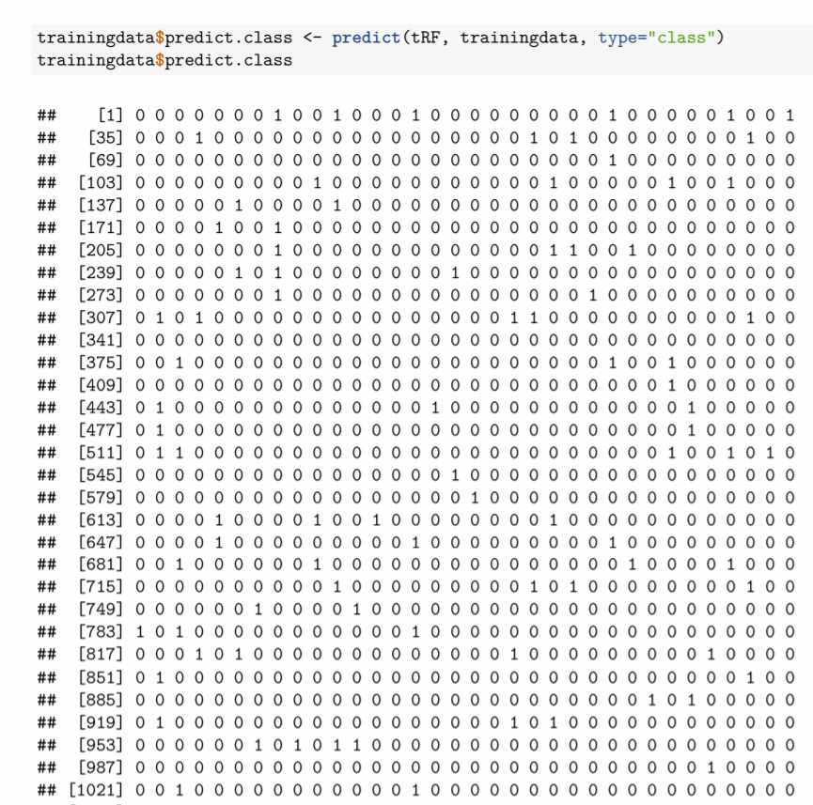

.

.

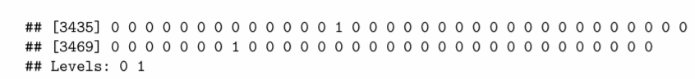

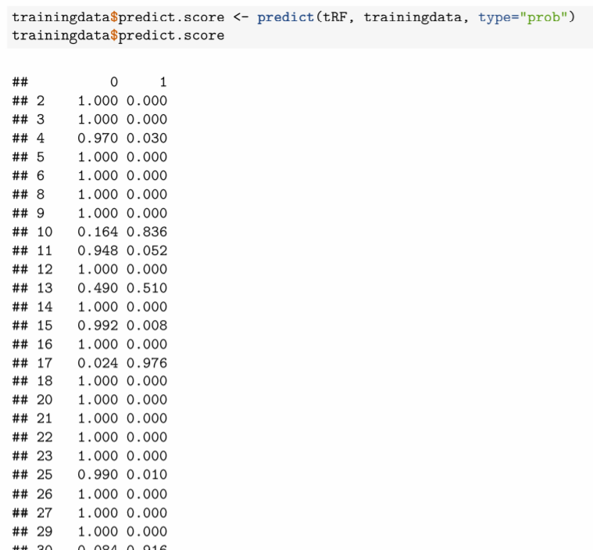

.

.

.

..

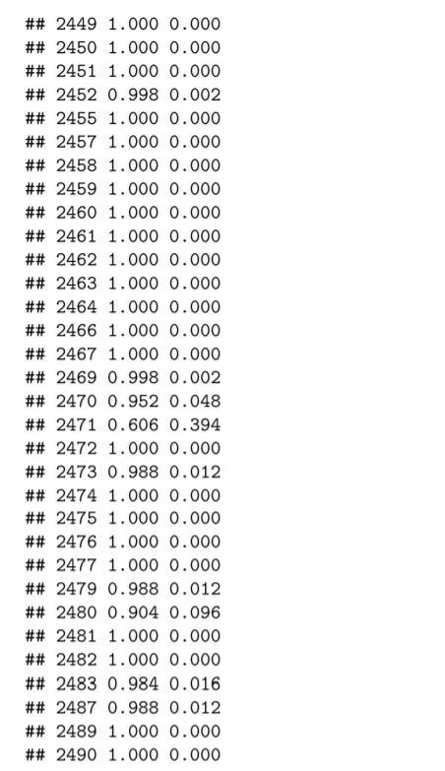

.

.

.

.

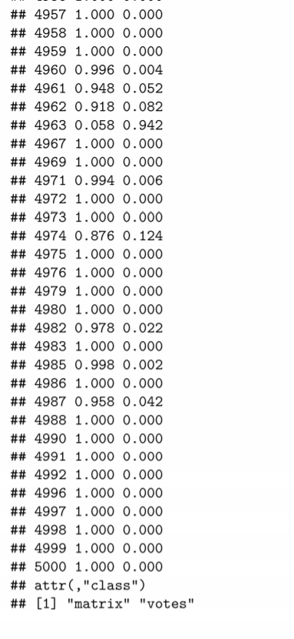 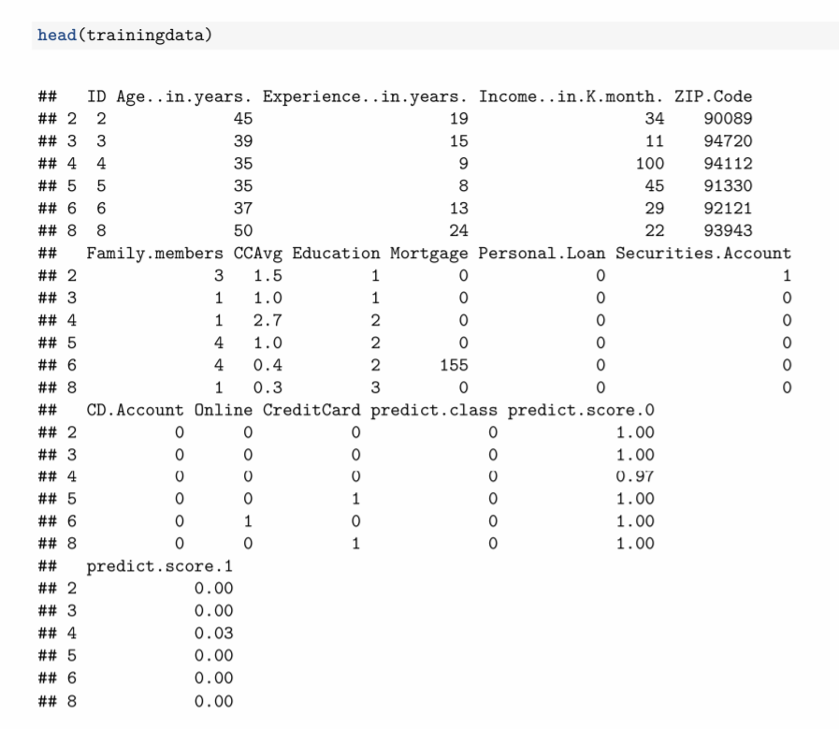

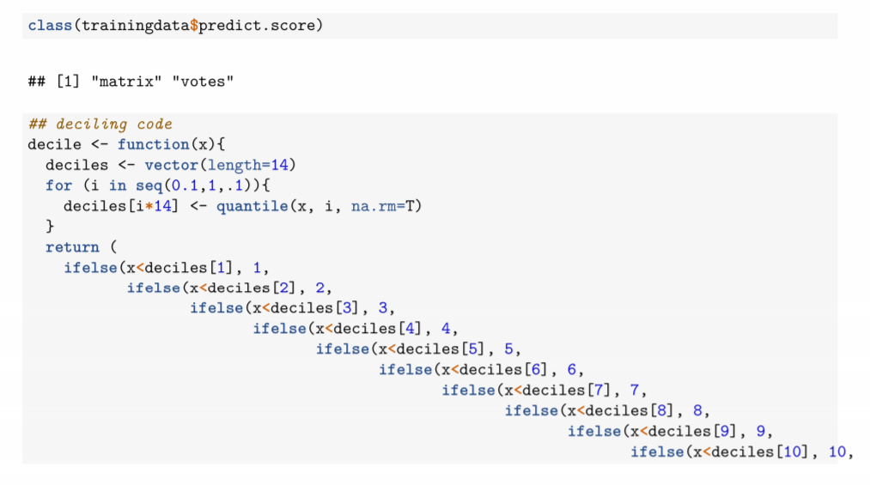 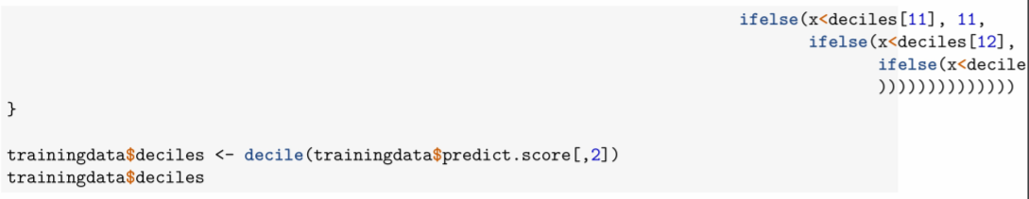

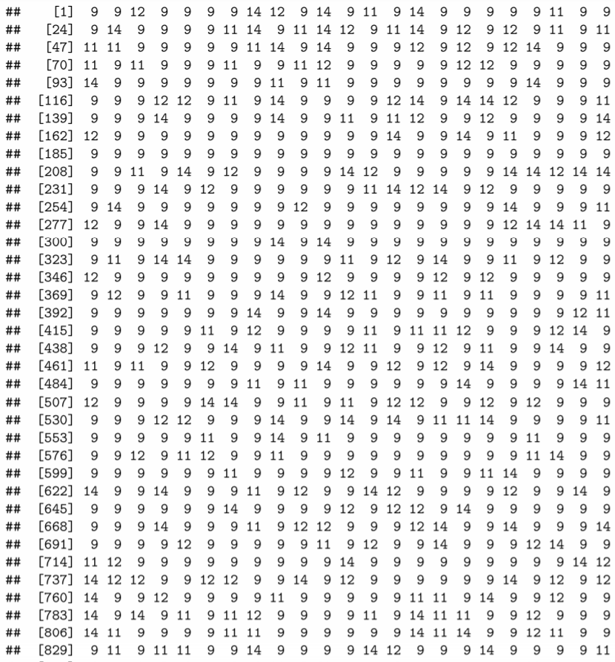

.

.

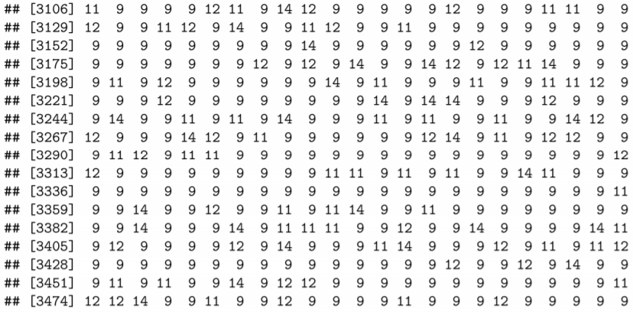 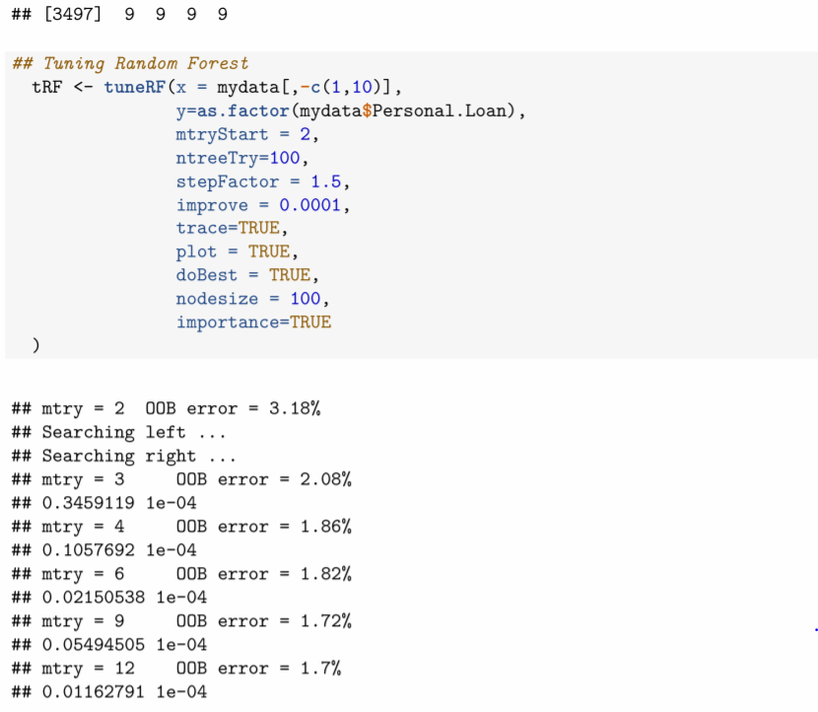 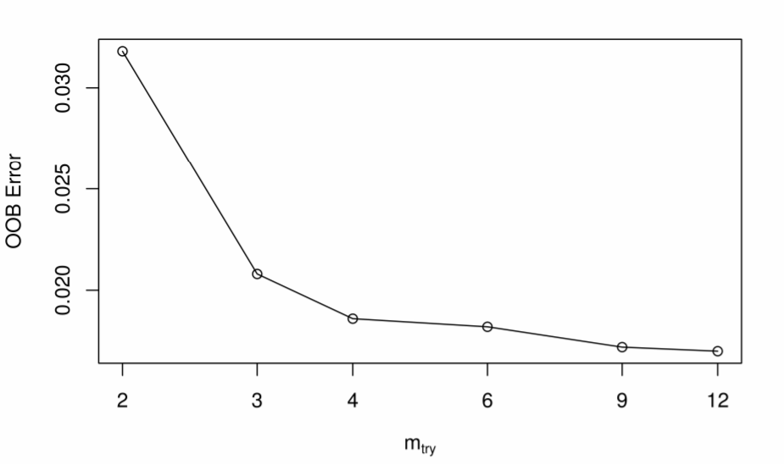

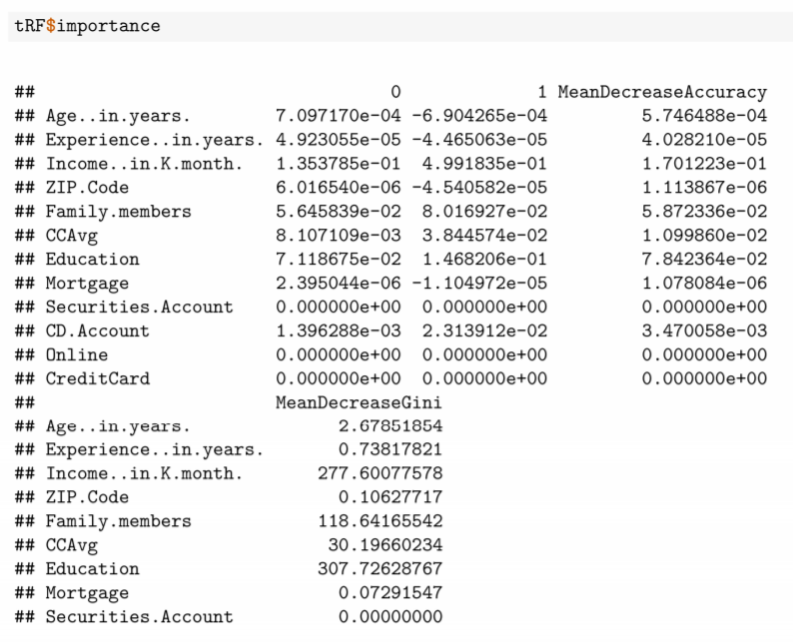

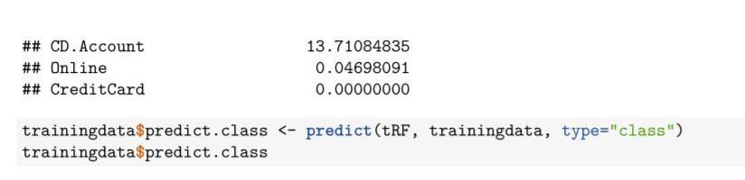 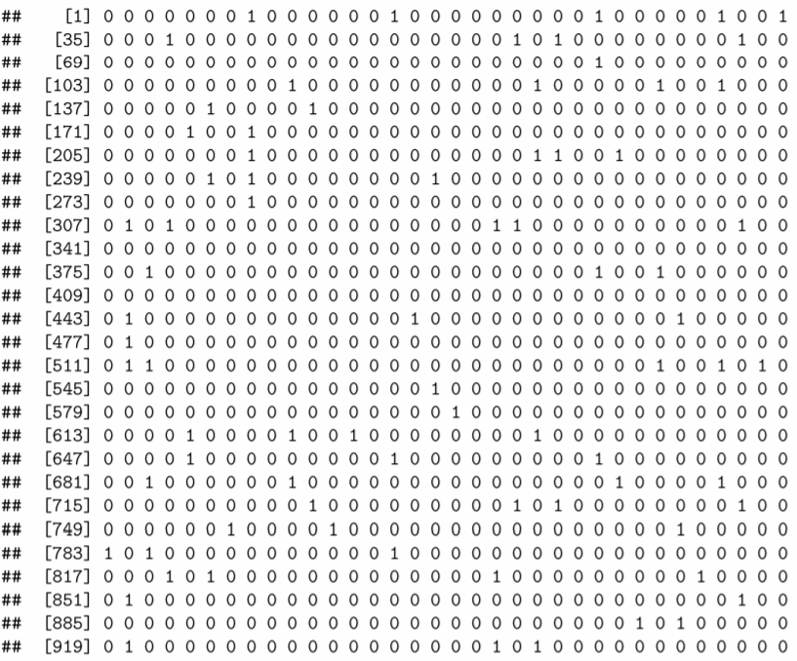

.

.

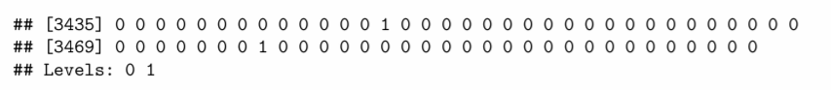 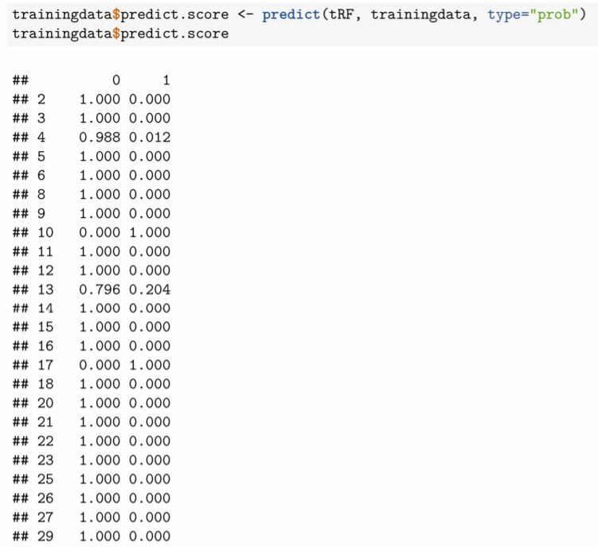

.

.

.

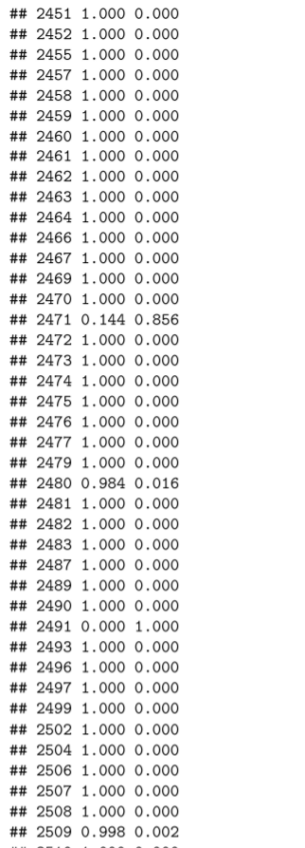

.

.

.

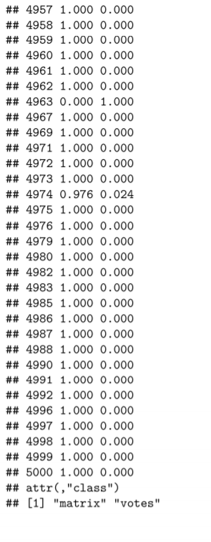

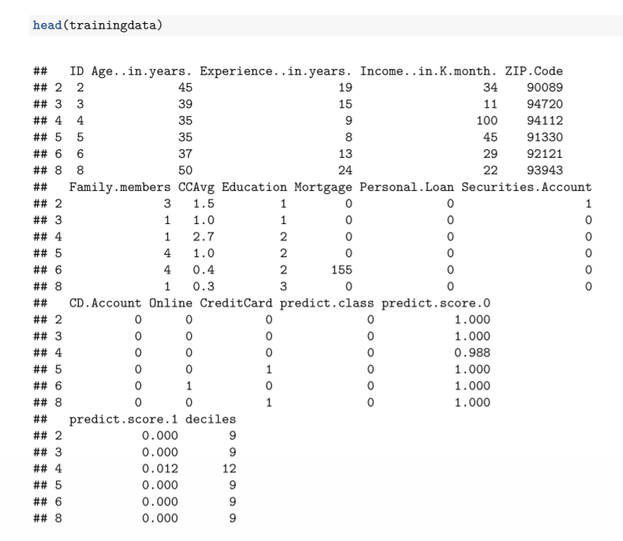 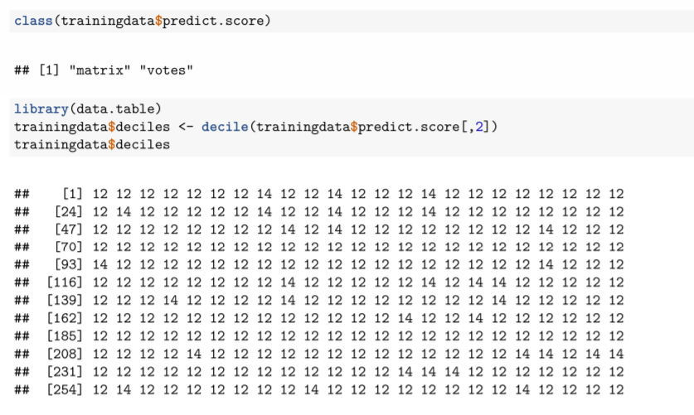

.

.

…

.

.

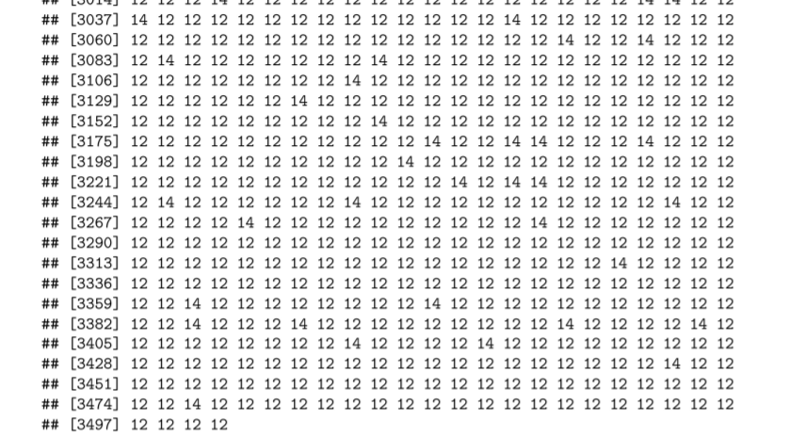

## 

**4.2 Validation of the Dataset**

* rmse1 <- sqrt((mean(model1$residuals^2)))
* rmse1
* pred=predict(model1, newdata = test, type = "response")
* test$Satisfaction.Predict <- pred
* head(test[c(1,6)],10)

cor(test$Satisfaction, test$Satisfaction.Predict)^2

* rmse2 <- sqrt(mean((test$Satisfaction - pred)^2))
* rmse2

# Conclusion.

* Age is Highly correlated with Experience
* CCAvg is correlated with Income
* Random Forest Method have been performed
* Hence a model that will help identify the potential customers who have a higher probability of purchasing the loan have been build.
* This will increase the success ratio while at the same time reduce the cost of the campaign.
* The model is not overfit
* The model is valid

# Appendix – Source Code

# 

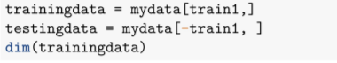

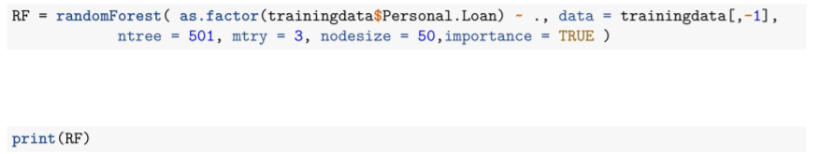

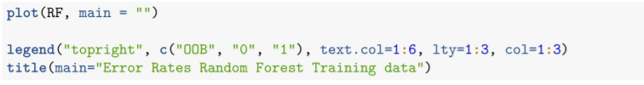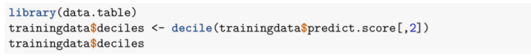

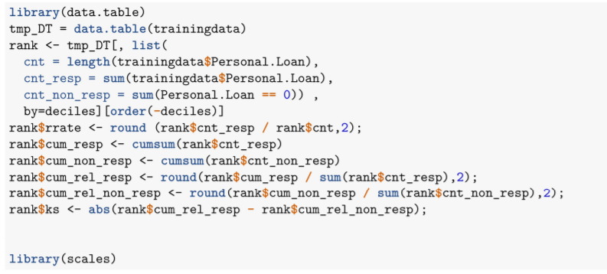



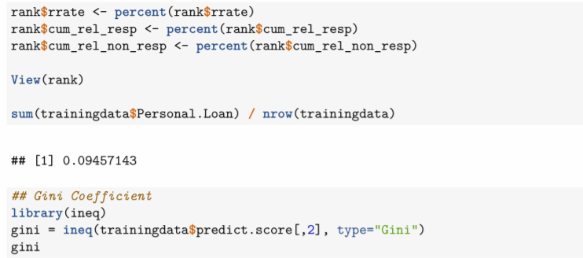



* + rmse1 <- sqrt((mean(model1$residuals^2)))
  + rmse1
  + pred=predict(model1, newdata = test, type = "response")
  + test$Satisfaction.Predict <- pred
  + head(test[c(1,6)],10)
  + cor(test$Satisfaction, test$Satisfaction.Predict)^2
  + rmse2 <- sqrt(mean((test$Satisfaction - pred)^2))
  + rmse2

**Important links for theory**

* Random Forest

<https://towardsdatascience.com/understanding-random-forest-58381e0602d2>

* Test and Train

<https://www.quora.com/In-machine-learning-what-s-the-purpose-of-splitting-data-up-into-test-sets-and-training-sets>

* CART Method

<https://www.datasciencecentral.com/profiles/blogs/introduction-to-classification-regression-trees-cart>

* Decision Tree

<https://towardsdatascience.com/understanding-random-forest-58381e0602d2>

* Machine Learning

<https://searchenterpriseai.techtarget.com/definition/machine-learning-ML>